York Country Club – NOW HIRING!
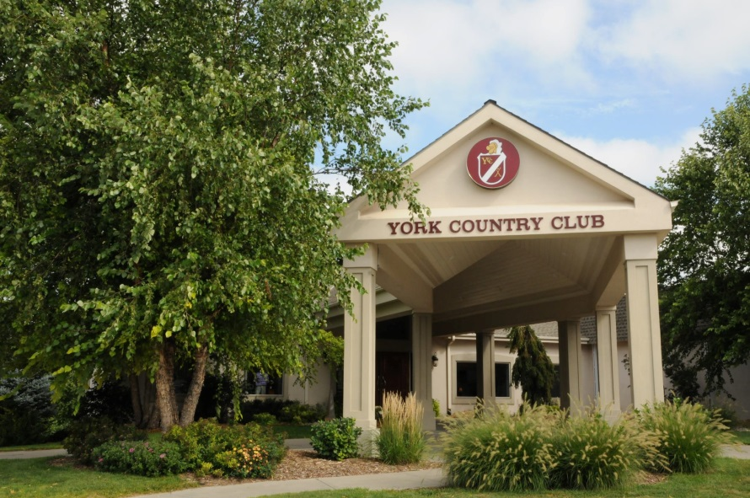
Come Join our Team! Now Hiring Prep Cook, Line Cook, Wait Staff, and Bartenders
Why Work with Us?
YCC is a hidden Nebraska gem. YCC offers a championship golf course and a newly remodeled dining facility, with over 200 members; our club is driven to provide the best service around. On top of our regular dining business, our club hosts a variety of events throughout the year including: wedding receptions, rehearsal dinners, business meetings, live music events, golf tournaments, and corporate banquets.
We believe in hiring the right people. We want to train you to succeed, both personally and professionally. With opportunities for advancement, we strive to value your talents. We’re looking for versatile team players with the drive to enhance our member experience.
What we offer?
Working for a country club does have its perks you can't find anywhere else.
- Free golfing privileges are provided up to twice a week.
- %50 off meals
- Opportunity for growth and career advancement
- Competitive Wages + Tips (based on experience)
- Paid vacation (after 1 year of service and avg. 35+ hrs per week)
Come join our team! Visit www.yorkcountryclub.net and click on the “Employment” tab to print off an application or stop by the club to pick one up.

